SUPPORTLYTICS - OPTIMIZING IT SUPPORT TEAM PERFORMANCE USING ANALYTICS

Submitted By Dharani Sree M

OBJECTIVE:

- The main objective of this project was to work with the IT support ticket dataset, prepare and clean the available data, perform similarity analysis and clustering, and develop an interactive Power BI dashboard.
- The project was completed through four milestones. The work started with loading and understanding the dataset, followed by data cleaning and feature preparation. The prepared data was then used for similarity analysis and clustering. Finally, the processed dataset was imported into Power BI and used to create a seven-page interactive dashboard.

KEY PERFORMANCE INDICATORS(KPI’S):
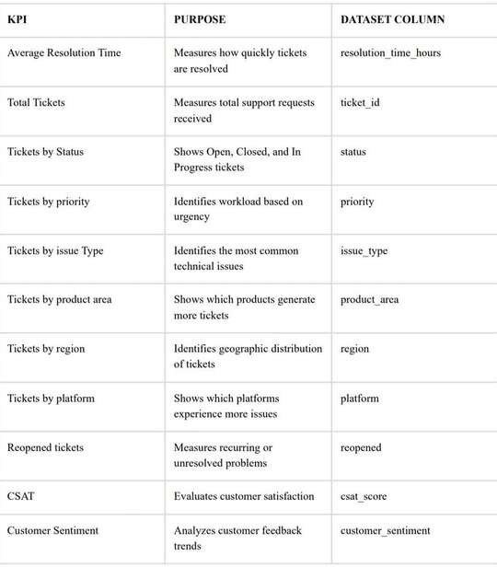
a

WORKFLOW:

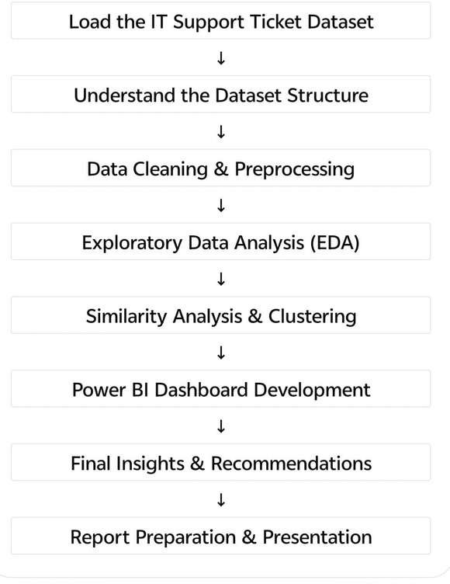

DATASET USED:

Dataset: IT Support Ticket Dataset
Source: Kaggle
File Format: CSV
Tool Used for Data Processing: Jupyter Notebook / Python
Tool Used for Visualization: Microsoft Power BI

Milestone 1 – Dataset Loading and Initial Exploration

Step 1: Opening Jupyter Notebook
I started the project by opening Jupyter Notebook. After launching Jupyter Notebook, I created a new Python notebook where I performed all the preprocessing and analysis work.

Step 2: Importing the Required Libraries
I imported the required Python libraries that were needed for data analysis and preprocessing.

import pandas as pd import numpy as np
These libraries were used throughout the project for handling the dataset and performing various preprocessing operations

Step 3: Loading the Dataset
I loaded the IT support ticket dataset into a pandas DataFrame.
df = pd.read_csv("cleaned_it_support_tickets.csv")
After executing this code, the dataset was successfully loaded into the DataFrame named df.

Step 4: Viewing the First Few Records
After loading the dataset, I displayed the first five rows to verify that the dataset had been imported correctly.

df.head()
This helped me understand the structure of the dataset and the available columns
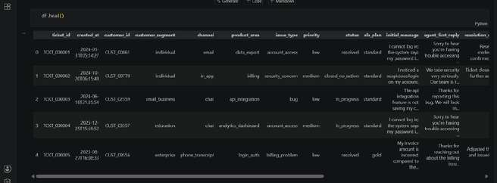

Step 5: Checking the Column Names
I checked all the column names available in the dataset.

df.columns
The dataset contained columns such as ticket_id, category, priority, region, platform, channel, created_at, csat_score, Performance_Score, Similarity_Score, cluster, and other related fields.
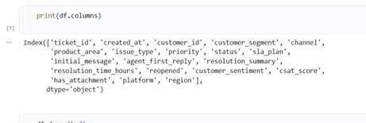

Step 6: Checking the Dataset Information
I examined the dataset information to understand the data types and the number of records available.

df.info()
This step allowed me to identify numeric and categorical columns and check whether any missing values were present.
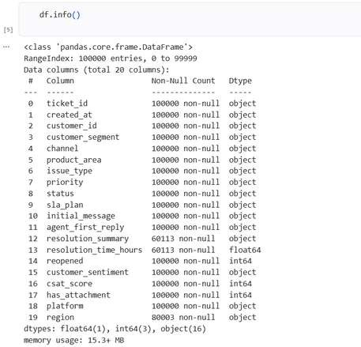


Step 7: Checking the Dataset Shape
I checked the number of rows and columns present in the dataset.

df.shape
This helped me confirm the total number of records available before starting the preprocessing work.
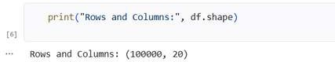

Step 8: Viewing Statistical Summary

I generated the statistical summary of the numeric columns.

df.describe()
This displayed the mean, standard deviation, minimum value, maximum value, and other statistical information for the numerical columns.
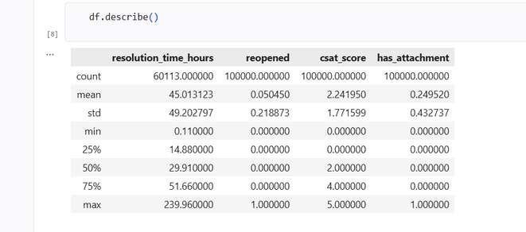

Step 9: Checking Missing Values
checked whether the dataset contained any missing values.

df.isnull().sum()
This step helped me identify the columns that required cleaning and preprocessing

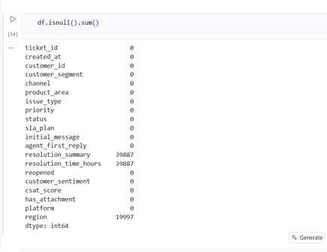

Step 10: Displaying Sample Records

I displayed additional records from the dataset to better understand the data.

df.sample(5)
This helped me inspect random records from different categories and regions.

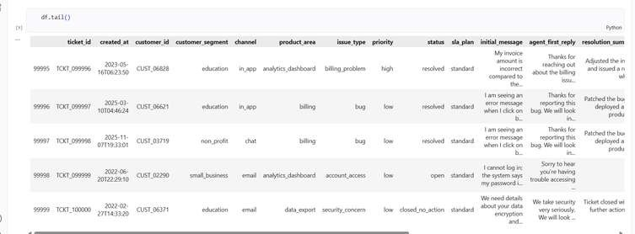
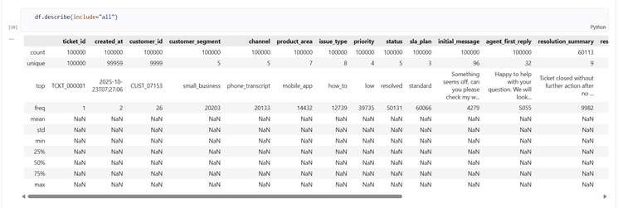

Step 11: Verifying the Dataset

I verified that the dataset was loaded correctly and confirmed that all required columns were available before proceeding to the cleaning process.
At this stage, I completed the initial exploration of the dataset and prepared it for preprocessing in Milestone 2.
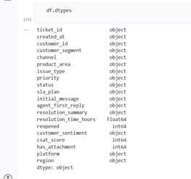
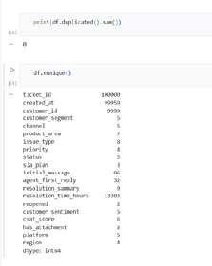

Step 12: Checking Missing Values

After completing the initial exploration, I started the data cleaning process by checking the missing values present in the dataset.

df.isnull().sum()
I reviewed the output carefully to identify which columns contained missing values and required preprocessing.


Step 13: Filling the Missing Values
After identifying the missing values, I filled the missing values in the dataset instead of deleting the rows containing them.
I applied the missing-value treatment to the required columns and then checked the dataset again to verify that the missing values had been handled

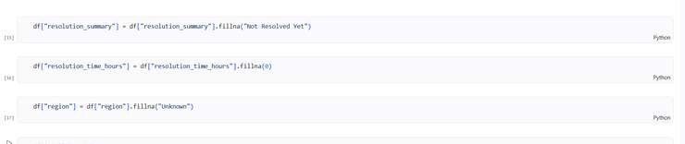

Step 14: Verifying Missing Values After Filling
After filling the missing values, I performed another missing-value check to verify the result.

df.isnull().sum()
I checked the output and confirmed that the missing-value treatment had been applied before continuing with the remaining preprocessing steps.

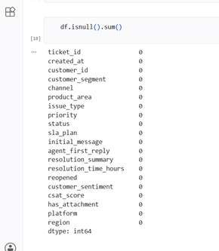

Step 15: Checking Duplicate Records
I checked whether duplicate records were present in the dataset.

df.duplicated().sum()
I reviewed the result before continuing with the preprocessing process.
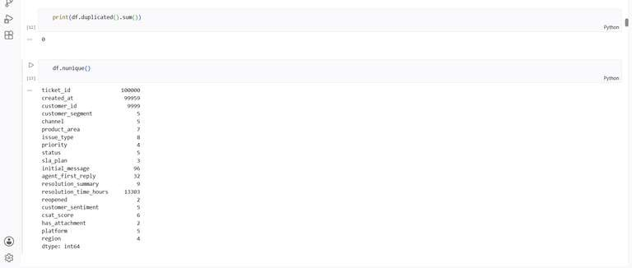

Step 16: Handling Duplicate Records
I handled the duplicate records identified during the data-cleaning process and then verified the dataset again.

Step 17: Checking Data Types
I checked the data types of all the columns in the dataset.

df.dtypes
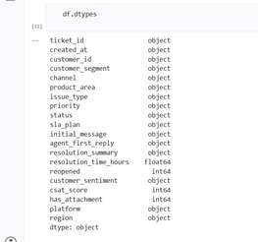
This allowed me to identify the numerical, categorical, and date/time fields that were required for the next stages of preprocessing.


Step 18: Checking the Dataset After Cleaning
I displayed the dataset after the missing-value and duplicate-record handling steps to verify that the data was ready for further processing.

df.head()
I reviewed the records and confirmed that the cleaned dataset could be used for the next feature-preparation steps.

Step 19: Exploring Product Values
At this stage, I checked the product column available in the original dataset to understand the different products associated with the IT support tickets.
df['product'].value_counts()
I reviewed the output to identify the different product values and their corresponding ticket counts.
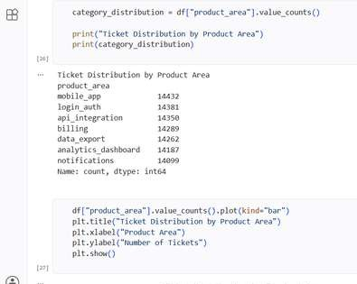
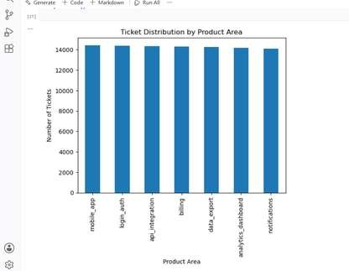

Step 20: Exploring Issue Type

I then checked the issue_type column to understand the different types of issues recorded in the dataset.
df['issue_type'].value_counts()
I reviewed the different issue types and their corresponding ticket counts.

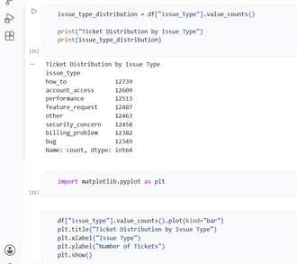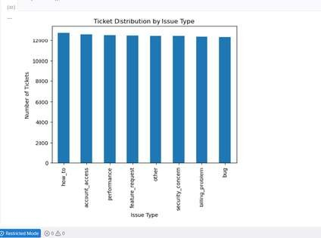

Step 21: Exploring Priority
I checked the priority column to understand the priority levels available in the original dataset.

df['priority'].value_counts()

I reviewed the different priority levels and their ticket counts.
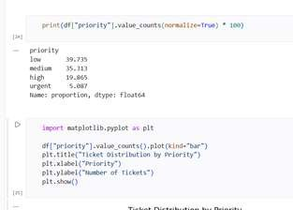
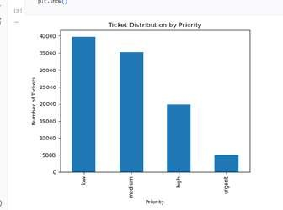

Step 22: Checking Status Distribution
I checked the number of tickets under each status.

df["status"].value_counts()
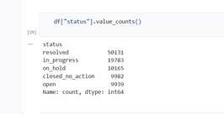

Step 23: Checking Issue Type Distribution

I again checked the issue-type distribution after the preprocessing and initial analysis steps.

df["issue_type"].value_counts()
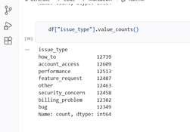

Step 24: Checking Product Area Distribution

I verified the product-area values again using:
df["product_area"].value_counts()

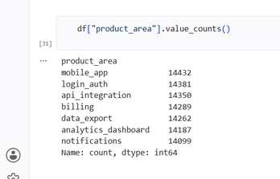

PREPARING THE CLEANED DATASET

Step 25: Saving the Cleaned Dataset
After completing the initial cleaning and distribution analysis, I saved the processed dataset as a CSV file.
df.to_csv("cleaned_it_support_tickets (2).csv", index=False)
The cleaned dataset was saved without including the Pandas index.

FEATURE ENGINEERING

Step 26:Creating Resolution_Duration
After saving the cleaned dataset, I created a new feature named:
Resolution_Duration
I created this column from the existing resolution_time_hours column.
df["Resolution_Duration"] = df["resolution_time_hours"]
This created a separate field that was later used in the dashboard for resolution-time analysis
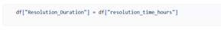

Step 27: Verifying Resolution_Duration
I verified the newly created column by displaying it together with the original resolution-time column.
df[["resolution_time_hours", "Resolution_Duration"]].head()
This allowed me to check that the values in the newly created column corresponded to the original resolution-time values.
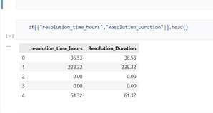

Step 28: Creating Priority_Score
I converted the priority categories into numerical values. I created the mapping using:

priority_mapping = { "low": 1,
"medium": 2,
"high": 3,
"urgent": 4
}
df["Priority_Score"] = df["priority"].map(priority_mapping)

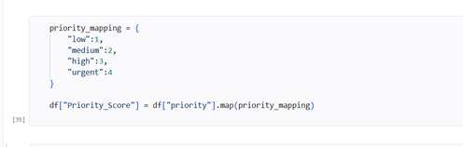

Step 28 : Verifying Priority_Score
I checked the original priority values together with their newly assigned numerical scores.

df[["priority", "Priority_Score"]].head(10)

This allowed me to verify that the priority categories had been correctly converted into numerical values.
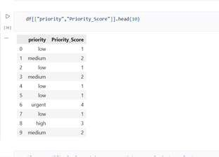

Milestone 1 – Deliverables
- Dataset Exploration Completed
- Data Cleaning and Missing-Value Handling Completed
- Duplicate Records Checked
- Feature Engineering Completed
- Resolution Duration Field Created
- Priority Score Field Created
- Ticket Distribution Analysis Completed
- Priority, Product Area, and Issue Type Analysis Completed
- Initial Data Visualizations Created
- Cleaned Dataset Prepared for the Next Milestone

Milestone 1 Summary

Milestone 1 focused on exploring and preparing the IT Support Ticket dataset for further analysis. I performed data cleaning, handled missing values, checked duplicate records, and completed the required feature engineering by creating the Resolution Duration and Priority Score fields. I also analyzed ticket distributions based on priority, product area, and issue type and created the initial visualizations. The cleaned and prepared dataset was then finalized for use in the subsequent milestones.

MILESTONE 2 – EXPLORATORY DATA ANALYSIS, SIMILARITY AND CLUSTER INSIGHTS

Step 1: Loading the Cleaned Dataset

I started Milestone 2 by loading the cleaned dataset prepared during Milestone 1.

import pandas as pd
df = pd.read_csv("final_cleaned_it_support_tickets.csv") df.head()
I displayed the first few records to verify that the cleaned dataset was loaded successfully.
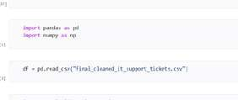
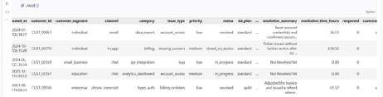

Step 2: Importing Matplotlib

I imported Matplotlib to create the visualizations required for the exploratory analysis.
import matplotlib.pyplot as plt

Step 3: Ticket Type Distribution

I analyzed the issue_type column to determine the number of tickets associated with each issue type.
issue_type_distribution = df["issue_type"].value_counts() print("Ticket Distribution by Issue Type") print(issue_type_distribution)

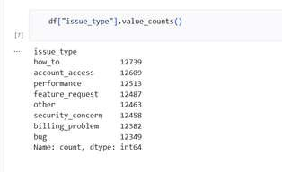

Step 4: Creating Ticket Type Visualization
I created a bar chart to visualize the ticket distribution by issue type.

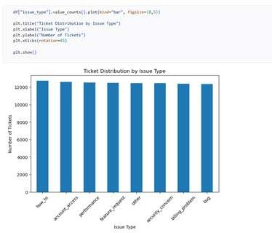

Step 5: Renaming Product Area to Category
After the ticket-type analysis, I renamed the product_area field to category. This was the stage where I started using category instead of product_area.

Step 6: Category Distribution
I calculated the frequency of each category.

Step 7: Creating Category Visualization
I created a bar chart to visualize the ticket distribution by category.

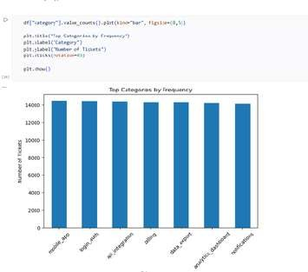

Step 8: Priority Distribution
I calculated the number of tickets for each priority level.

Step 9: Creating Priority Visualization
I created a visualization to compare the number of tickets across the different priority levels.

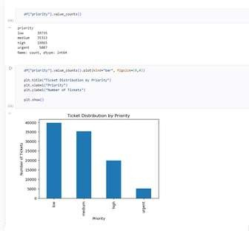

Step 10: Queue Distribution
I calculated the number of tickets assigned to each support queue.

Step 11: Creating Queue Visualization
I created a visualization to compare the workload across the different support queues.
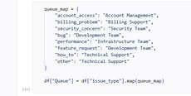

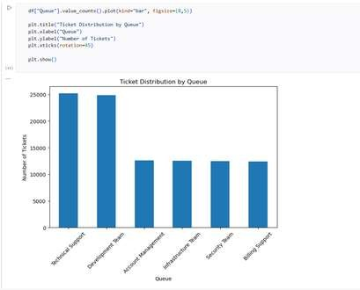

Step 12: Importing TF-IDF Vectorizer

After completing the exploratory visualizations, I moved to text processing. I imported TfidfVectorizer from Scikit-learn.

Step 13: Selecting Initial Message
I selected the initial_message column for text processing.

Step 14: Applying TF-IDF Vectorizer

I created the TF-IDF Vectorizer and transformed the ticket messages into numerical text features.

Step 15: Generating Similarity Score
After generating the TF-IDF matrix, I created the Similarity_Score field.

Step 16: Verifying Similarity Score
I displayed the generated similarity scores to verify the newly created field.

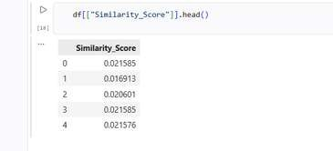

Step 17: Importing K-Means
I imported the K-Means algorithm from Scikit-learn.

Step 18: Preparing the Clustering Feature
I used the generated Similarity_Score as one of the features for clustering.
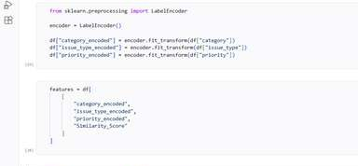

Step 19: Applying K-Means Clustering
I applied the K-Means algorithm to group tickets with similar characteristics. This created the Cluster column containing the cluster assignment for each ticket.
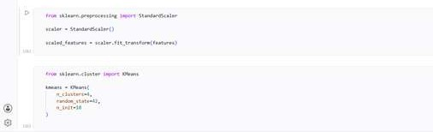

Step 20: Creating Cluster Name
After assigning the Cluster IDs, I created a Cluster Name field.
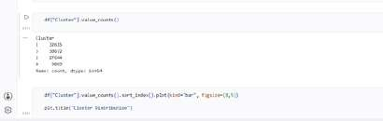

Step 21: Comparing Cluster Size
I calculated the number of tickets belonging to each cluster.

Step 22: Comparing Issue Type Frequency Within Clusters
I compared the issue types within each cluster.
This showed the frequency of different issue types within each cluster.
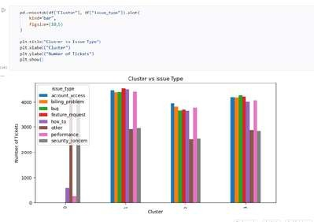
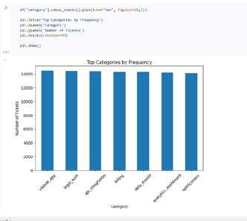

Step 23: Creating Box Plot
I created a Box Plot as part of the cluster performance analysis.

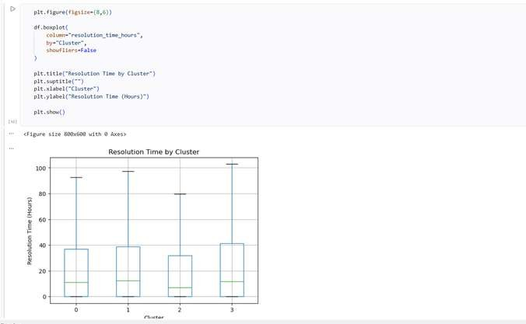


Step 24: Creating Scatter Plot
I created a Scatter Plot to visualize the relationship between the cluster assignments and similarity scores.
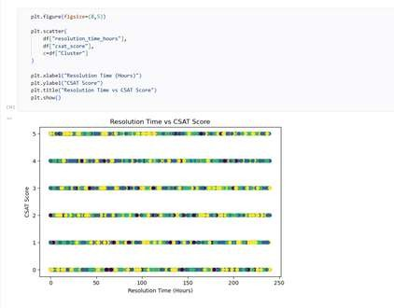

MILESTONE 2 – FINAL OUTPUT
After completing the above steps, Milestone 2 produced the following outputs:
- Ticket Type Distribution
- Category Distribution
- Priority Distribution
- Queue Distribution
- TF-IDF Feature Extraction
- Similarity Score Generation
- K-Means Clustering
- Cluster ID creation
- Cluster Name creation
- Cluster Size Analysis
- Issue Type by Cluster Analysis
- Average Similarity Score by Cluster
- Box Plot
- Scatter Plot
- Distribution and Outlier Analysis

MILESTONE 3 – PERFORMANCE TREND AND GEOGRAPHIC & CATEGORY-LEVEL INSIGHTS

Step 1: Analysing Average Resolution Time by Priority
I grouped the tickets based on the priority field and calculated the average resolution time for each priority level.
The resolution_time_hours field was used to calculate the average time taken to resolve tickets.
I then created a visualization to compare the average resolution time across Low, Medium, High, and Urgent priority tickets.
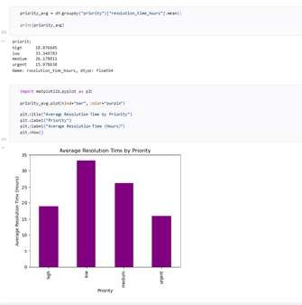

Step 2: Analysing Average Resolution Time by Issue Type
I grouped the tickets according to their issue_type and calculated the average resolution time for each issue type.
I visualized the results using a bar chart.
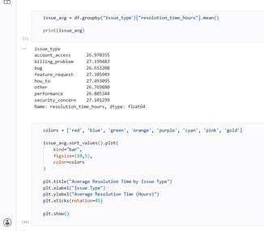
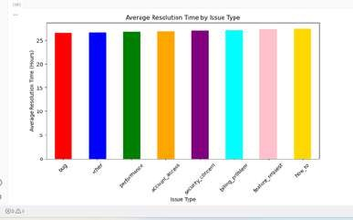

Step 3: Analysing Regional Resolution Time
I grouped the tickets by region and calculated the average resolution time for each region. I created a comparative visualization to evaluate resolution efficiency across regions.
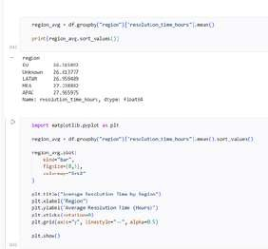
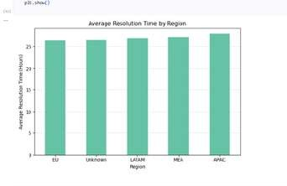

Step 4: Analysing Queue Performance
I grouped the tickets based on the Queue field and calculated the average resolution time
I fcorreaetaecdhasuvpispuoarltizqautieoune.to compare the resolution efficiency of the different support queues.

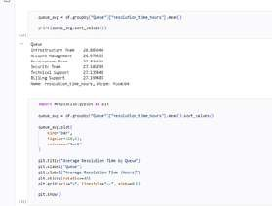
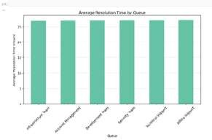

Step 5: Filtering High-Priority Unresolved Tickets

I filtered the dataset to identify High-priority tickets that were still unresolved.

I reviewed the resulting records to identify the unresolved High-priority support requests.
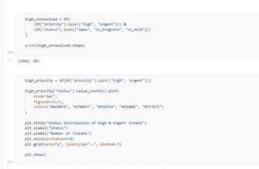
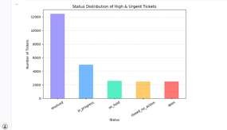

Step 6: Filtering Urgent-Priority Unresolved Tickets
I then filtered the dataset to identify Urgent-priority tickets that were still unresolved.
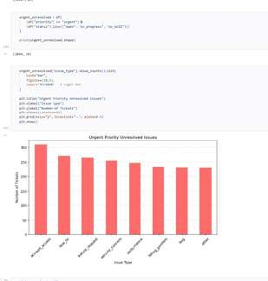

Step 7: Analysing Unresolved Issues by Issue Type
I counted the unresolved High and Urgent tickets according to their issue_type. I created separate visualizations for High and Urgent unresolved issues.

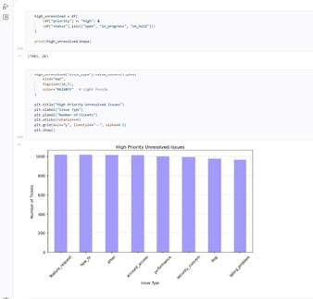

Step 8: Standardizing Region Names
I prepared the region field so that the regional values could be used consistently for geographic analysis.
I reviewed the region values before performing the regional ticket analysis.
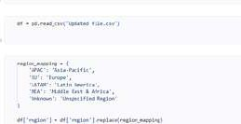
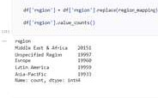

Step 9: Regional Ticket Concentration Analysis
I calculated the number of support tickets generated by each region.
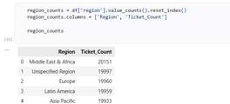

Step 10: Creating Regional Ticket Concentration Visualization
I created a visualization to display ticket concentration across the different regions.

Step 11: Assigning Latitude and Longitude
To visualize the ticket distribution geographically, I assigned latitude and longitude coordinates to the different regions.
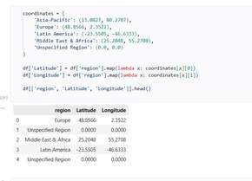
The coordinates were used to represent the regional ticket locations on a geographic visualization.

Step 12: Creating Geographic Ticket Visualization
I used the latitude and longitude information to create a global geographic visualization of the support tickets.
The visualization was used to identify geographic concentrations of support tickets.
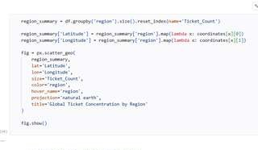
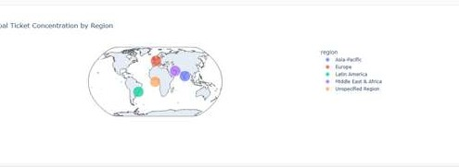

Step 13: Mapping Issue Categories Across Regions
I analyzed the distribution of issue categories across different regions.
The category, region, latitude, and longitude information was used to understand how different ticket categories were distributed geographically.
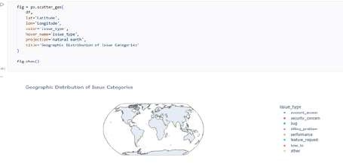

Step 14: Using the Clusters Generated in Milestone 2
I used the clusters created during Milestone 2 for further performance analysis.
The existing Cluster field was used to compare cluster size with customer performance.

Step 15: Creating Performance Score
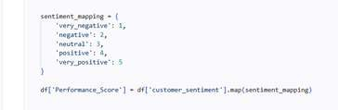
I converted customer sentiment into a numerical Performance Score. I converted customer sentiment into a numerical Performance Score.

Step 16: Calculating Cluster Size
I calculated the number of tickets belonging to each cluster.
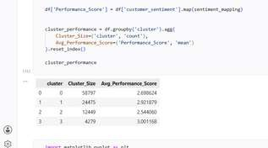

Step 17: Calculating Average Performance Score by Cluster
I calculated the average Performance Score for each cluster.
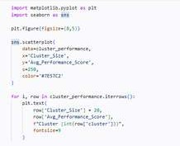

Step 18: Creating Cluster Performance Scatter Plot
I created a Scatter Plot to compare cluster size with average Performance Score.

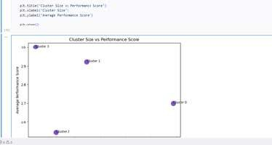

Step 19: Calculating Average Resolution Time by Region
I calculated the average resolution time for each region.

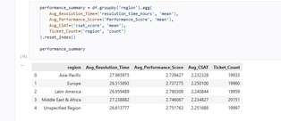
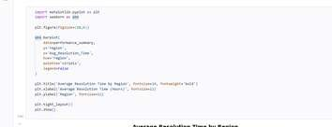
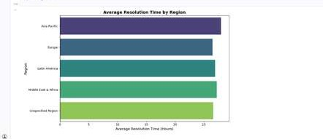

Step 20: Calculating Average Performance Score by Region
I calculated the average Performance Score for each region.

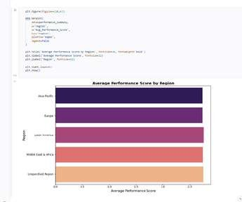

Step 21: Calculating Average CSAT Score by Region
I calculated the average CSAT score for each region.

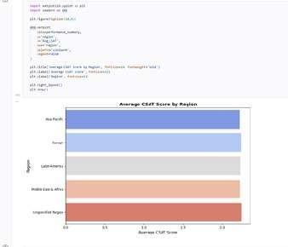

Step 23: Creating Comparative Regional Charts
I created comparative visualizations for the regional performance metrics.

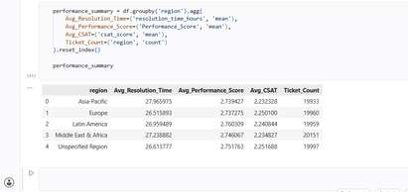

MILESTONE 3 – FINAL OUTPUT

After completing Milestone 3, I analyzed both ticket performance trends and geographic support patterns. The work covered resolution-time analysis across priority, issue type, region, and queue; High and Urgent unresolved-ticket analysis; regional ticket concentration; geographic ticket visualization; issue-category geographic analysis; cluster performance; and regional performance metrics.

Milestone 3 Deliverables

- The final deliverables of Milestone 3 were:
- Resolution Time Analysis Completed
- Regional & Queue Performance Evaluation Completed
- High & Urgent Ticket Analysis Completed
- Geographic Ticket Visualization Completed
- Cluster Performance Evaluation Completed
- Performance Metrics Summary Generated
- Comparative Regional Charts Created

Milestone 3 Summary

Milestone 3 extended the Supportlytics analysis by evaluating performance trends, resolution efficiency, unresolved critical tickets, regional workload, geographic ticket distribution, cluster performance, and regional customer-performance metrics. The completed analyses provided a detailed view of operational performance across
different regions, queues, priorities, issue types, and ticket clusters

MILESTONE 4 – POWER BI DASHBOARD DEVELOPMENT

Step 1: Importing the Final Dataset into Power BI
I started Milestone 4 by importing the final processed dataset into Power BI Desktop.
I selected the cleaned dataset prepared during the previous milestones and loaded it into Power BI so that the analytical fields and calculated metrics could be used for dashboard development.

Step 2: Checking the Available Fields
After importing the dataset, I reviewed the available fields in the Power BI Fields/Data pane. The dataset contained the fields required for dashboard development, including ticket information, category, channel, customer segment, customer sentiment, issue type, region,
priority, resolution time, CSAT score, Performance Score, Similarity Score, and Cluster-related fields.

Step 3: Creating the Dashboard Structure
I created multiple dashboard pages in Power BI to organize the analysis into different sections.
The dashboard was divided into pages covering:
- Executive Overview
- Resolution Time Analysis
- Ticket Categories & Geographic Insights
- Cluster/Summary Analysis
- Regional Performance
- Additional Analytical Insights
- Final Insights & Recommendations

PAGE 1 – EXECUTIVE OVERVIEW

Step 4: Creating KPI Cards
I created KPI cards to display the important overall performance indicators. The cards were used to present values such as:
- Average CSAT
- Average Performance Score
- Average Resolution Time
- Average Similarity Score

Step 5: Creating Category Visualization
I created a category-based visualization to display the distribution of support tickets across different categories.
This helped present the most frequently occurring ticket categories in the overall dataset.

Step 6: Creating Priority Distribution Visualization
I created a visualization to show how tickets were distributed across the different priority levels.
This provided an overview of the workload according to ticket priority.

Step 7: Creating Regional Ticket Ranking
I created a regional ranking visual to compare the number of tickets across different regions. This allowed the regions with higher ticket volumes to be identified

Step 8: Creating Ticket Trend Visualization
created a line chart using the ticket creation date to display the ticket trend over time. This helped visualize changes in ticket volume across the selected time periods.

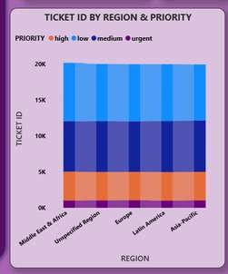
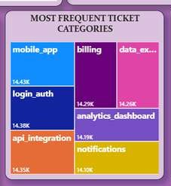
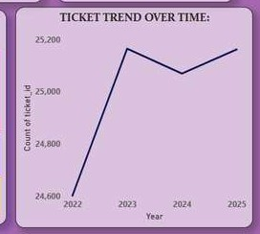
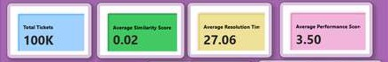

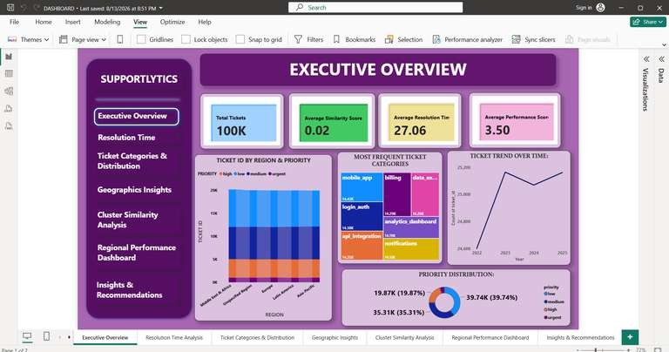

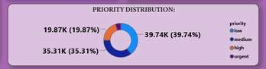

PAGE 2 – RESOLUTION TIME ANALYSIS

Step 9: Creating Resolution Time KPI

I created a KPI/card visual to display the average resolution time.
The resolution_time_hours field was used with the Average aggregation.

Step 10: Analysing Resolution Time by Priority
I created a chart comparing average resolution time across the different priority levels. I used:
  - priority as the category/axis
  - resolution_time_hours as the value
  - Average aggregation for resolution time

Step 11: Analysing Resolution Time by Issue Type

I created a chart to compare the average resolution time for different issue types. This allowed the issue types requiring longer resolution times to be identified.

Step 12: Analysing Regional Resolution

I created a regional resolution-time visualization using the region and resolution_time_hours fields.
This allowed the average resolution time across regions to be compared.

Step 13: Analysing Queue Performance

I created a visual to compare resolution performance across support queues.
The Queue field was used to compare the average resolution time for the different support teams.

Step 14: Creating Resolution Trend
I created a line-based visualization to display how resolution time changed over time. This provided a time-based view of support resolution performance.

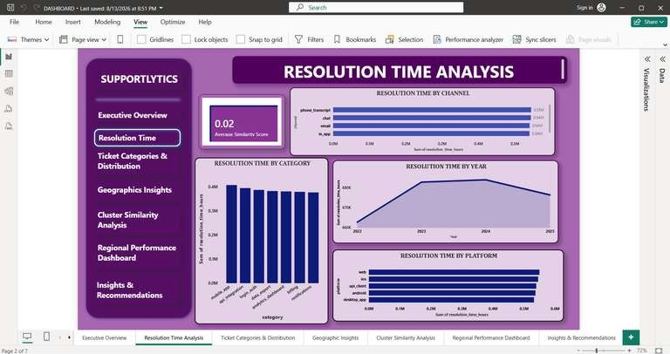
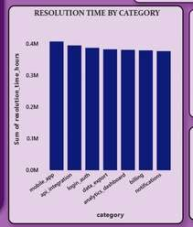
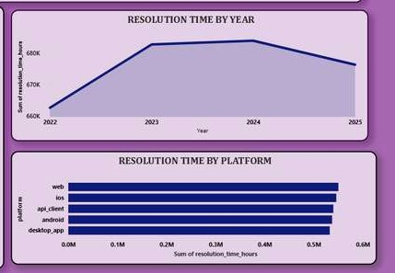
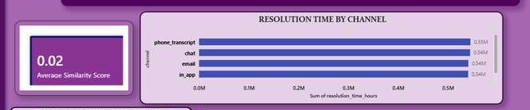

PAGE 3 – TICKET CATEGORIES & DISTRIBUTION

Step 15: Creating Category Distribution Visual
I created a category distribution visual to show the number of tickets belonging to different categories.
The category field was used to group the tickets.

Step 16: Creating Pie Chart
I created a Pie Chart to represent the distribution of tickets across the selected categories. The category field was used as the legend, while the ticket count was used as the value.

Step 17: Creating Ticket Ranking Visual
I created a ranking visualization to compare ticket volumes across the selected categories/regions.
This helped identify the highest-volume groups.

Step 18: Adding Category/Status Analysis
I added another visual to compare ticket distribution according to status.
This allowed the dashboard to show the distribution of tickets across different ticket states.

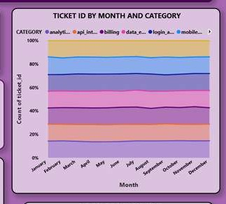
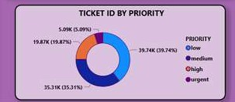
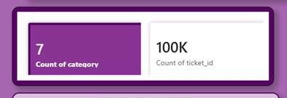

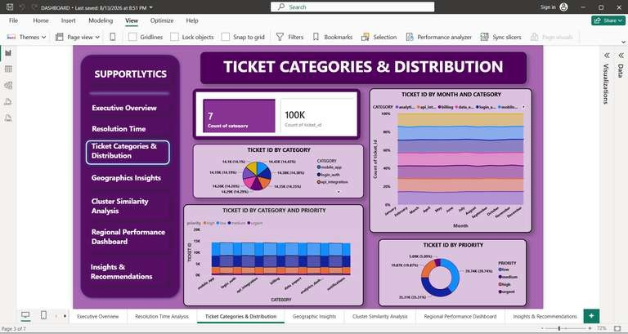
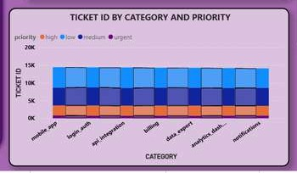
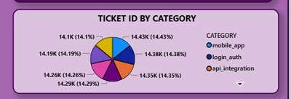

PAGE 4 – GEOGRAPHIC INSIGHTS

Step 19: Creating the Geographic Visual
I created a map-based visual to display the geographic distribution of support tickets. The region field was used as the location information.

Step 20: Adding Geographic Fields
For the map visual, I used the available geographic fields such as:
- Location/Region
- Latitude
- Longitude
- Tooltips
These fields were used to position and describe the ticket information geographically.

Step 21: Creating Regional Ticket Comparison
I created a separate regional comparison visual to show ticket volume across different regions.
This complemented the map by providing a direct comparison of regional workload.

Step 22: Adding Regional Category Information
I added category-related information to the geographic analysis to examine how ticket categories were distributed across regions.

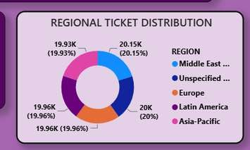
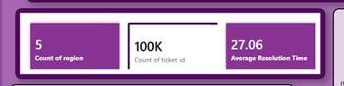
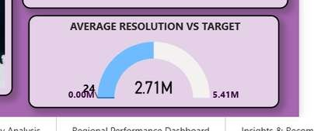

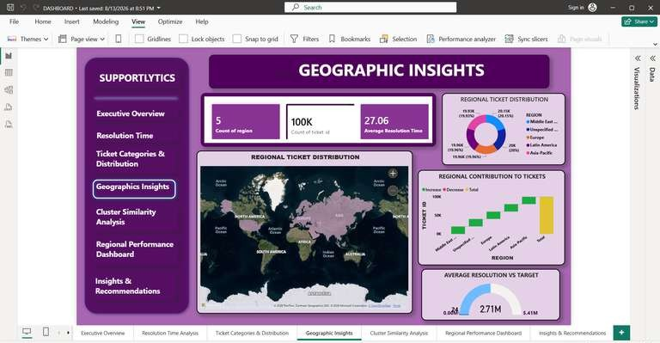
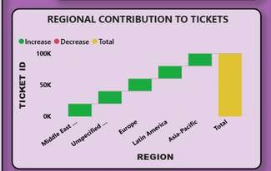
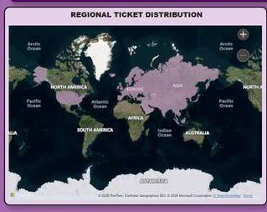

PAGE 5 – CLUSTER & SIMILARITY ANALYSIS

Step 23: Creating Similarity Score Visualization
I created a visualization using the Similarity_Score field generated during Milestone 2. This allowed the similarity patterns of the support tickets to be displayed in Power BI.

Step 24: Creating Cluster Visualization
I used the Cluster field generated during the clustering analysis to compare the different ticket groups.
The cluster information was incorporated into the dashboard to make the machine-learning output easier to interpret.

Step 25: Creating Scatter Chart
I created a Scatter Chart to compare cluster-related performance and similarity information.
The Scatter Chart helped visualize relationships between the selected numerical fields.

Step 26: Creating Cluster Comparison Visual

I created a bar/column-based visual to compare the number of tickets or performance values across the clusters.
This made it easier to identify differences between the generated ticket groups.

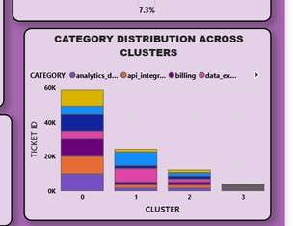
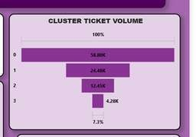
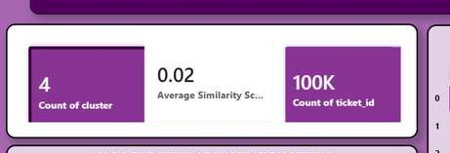
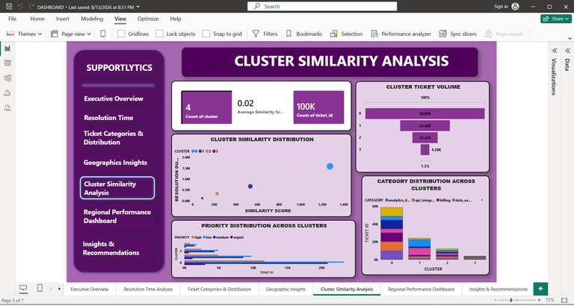

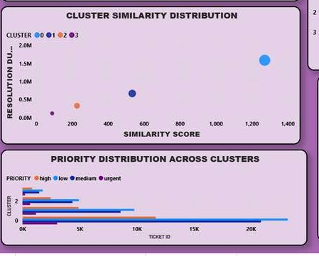

PAGE 6 – REGIONAL PERFORMANCE ANALYSIS

Step 27: Creating Average Performance Score Visual
I created a visual to compare the average Performance Score across regions.
The Performance Score field generated during Milestone 3 was used for this analysis.

Step 28: Creating Average CSAT Visual
I created a visualization to compare the average CSAT score across different regions. The csat_score field was aggregated using Average.

Step 29: Creating Regional Resolution-Time Visual
I created a visual comparing average resolution time across regions.
This allowed regional operational performance to be compared within the dashboard.

Step 30: Creating Regional Ticket Volume Visual

I created another visual to compare the total ticket volume across regions. This helped identify regions with relatively higher support workloads.
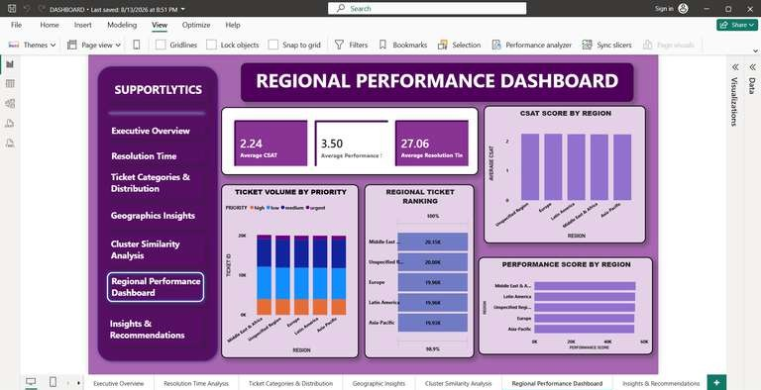

PAGE 7 – FINAL INSIGHTS AND
RECOMMENDATIONS

Step 31: Creating the Final Dashboard Page
I created the final page as a closing page for the dashboard rather than adding another set of KPI cards.
The page was designed to summarize the important findings obtained from the previous dashboard pages.

Step 32: Adding Key Findings
I summarized the major findings from the completed analysis, including:
- High-volume ticket categories
- Differences in resolution time
- Regional performance variations
- Cluster performance differences
- Customer satisfaction patterns
- Support workload distribution
These findings were based on the analyses completed during the earlier milestones.

Step 33: Adding Recommendations
I included recommendations based on the findings presented throughout the dashboard. The recommendations included:
- Allocating resources to high-volume regions
- Improving the handling of long-resolution categories
- Monitoring low-performing clusters regularly
- Optimizing support queue distribution

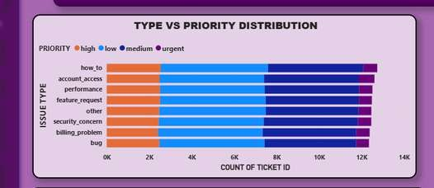
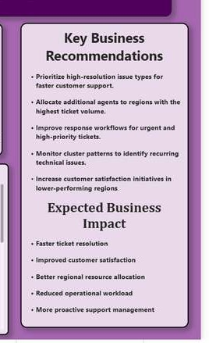
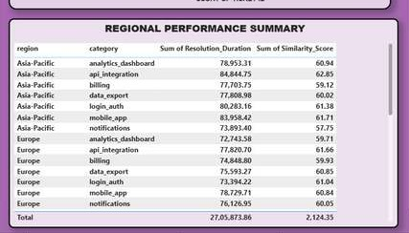

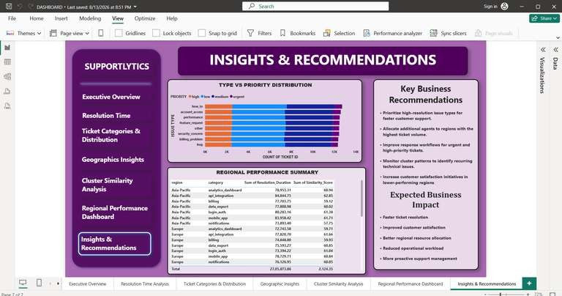

Step 34: Applying Dashboard Formatting
After creating the individual visuals, I formatted the dashboard pages to provide a consistent appearance.
I adjusted:
- Visual titles
- Font sizes
- Background
- Borders
- Alignment
- Spacing
- Chart sizes
- Slicers and filters
- Page headings
I also arranged the visuals so that the important information was easy to identify.

Step 35: Adding Interactivity
I configured the dashboard visuals so that selections and filters could be used to interact with the analysis.
The interactive dashboard allowed the displayed information to change according to the selected categories, regions, priorities, or other available fields.

Step 36: Final Dashboard Validation
After completing all dashboard pages, I reviewed the visuals to verify that:
- The correct fields were used.
- Aggregations were appropriate.
- Charts displayed the expected values.
- Filters worked correctly.
- Visuals were properly aligned.
- Page titles were clear.
- The dashboard maintained a consistent layout

MILESTONE 4 – FINAL OUTPUT
- At the end of Milestone 4, I completed the Power BI dashboard by integrating the analytical results generated during the previous milestones into an interactive dashboard solution.
- The dashboard covered Executive Overview, Resolution Time Analysis, Ticket Categories and Distribution, Geographic Insights, Cluster Similarity Analysis, Regional Performance, and final Insights & Recommendations. The PPT identifies these as the major dashboard sections.

Milestone 4 Summary
Milestone 4 completed the Supportlytics project by transforming the analytical results from
the previous milestones into a multi-page Power BI dashboard. The final dashboard presented ticket performance, resolution time, ticket categories, geographic distribution, cluster similarity, regional performance, and key findings through interactive visualizations, allowing the completed analysis to be presented in a clear and accessible format.

Milestone 4 Deliverables
The final deliverables of Milestone 4 were:
- Power BI Dashboard Completed
- Executive Overview Dashboard Created
- Resolution Time Analysis Dashboard Created
- Ticket Categories & Distribution Analysis Created
- Geographic Insights Dashboard Created
- Cluster Similarity Analysis Created
- Regional Performance Analysis Created
- Insights & Recommendations Page Created
- Interactive Visualizations Added
- KPI and Analytical Cards Created
- Charts and Graphs Integrated
- Final Dashboard Formatting Completed
- Dashboard Validated and Finalized
The dashboard combines the insights generated from the earlier milestones into a single interactive business-intelligence solution, which is the stated objective of Milestone 4.

